Darkness

By Quang Huynh

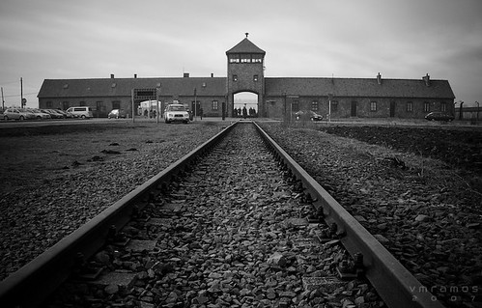

Darkness surrounds the light

As Jews tried to fight

There was no day, just night

Bread was the only thing good enough to bite

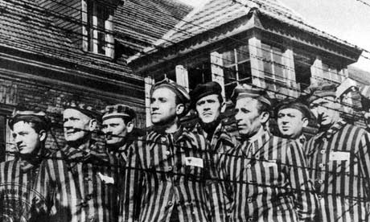

There is no delight

As the skin becomes white

Working day and night

The guards shouting, nothing polite

The Nazis violated human rights

When they killed Jews in the campsite

The Jews had lost their appetite

Food so scarce, stomachs so small and tight

In the winters, many perish of frostbite

Many don’t live past a fortnight

The days aren’t bright

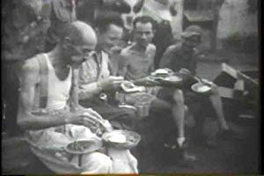As your chances to live becomes slight

No hope, no faith, no delight

Only soup and bread, no egg whites

No more kites

No more sunlight

Bonus haiku:

Gloomy holocaust

Taken lives of innocents

Jews were in a plight